# CS 255 System Design Document Template

## UML Diagrams

### UML Use Case Diagram

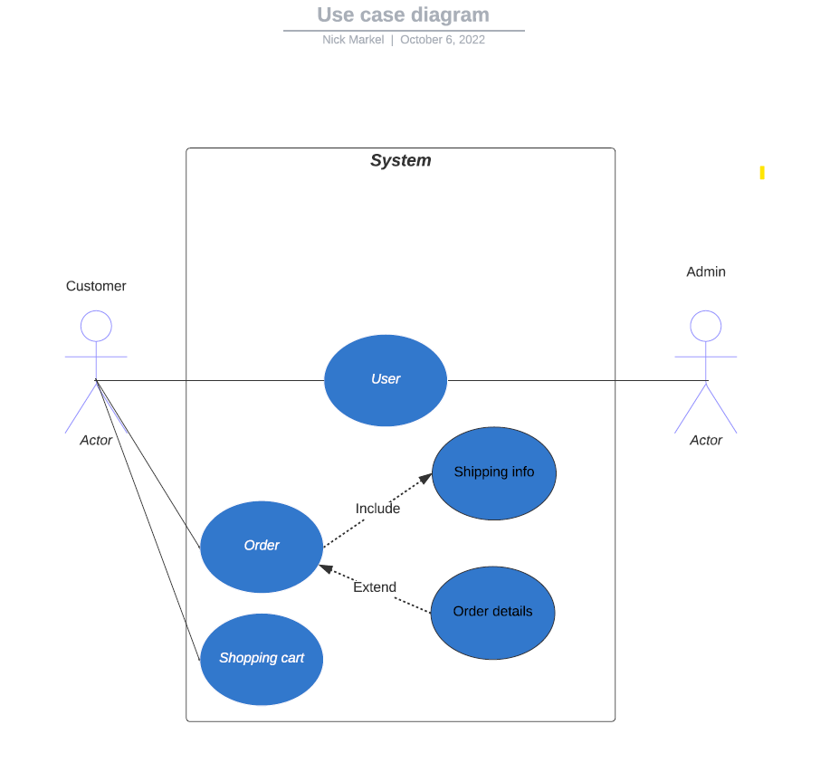

### UML Activity Diagrams

### UML Sequence Diagram

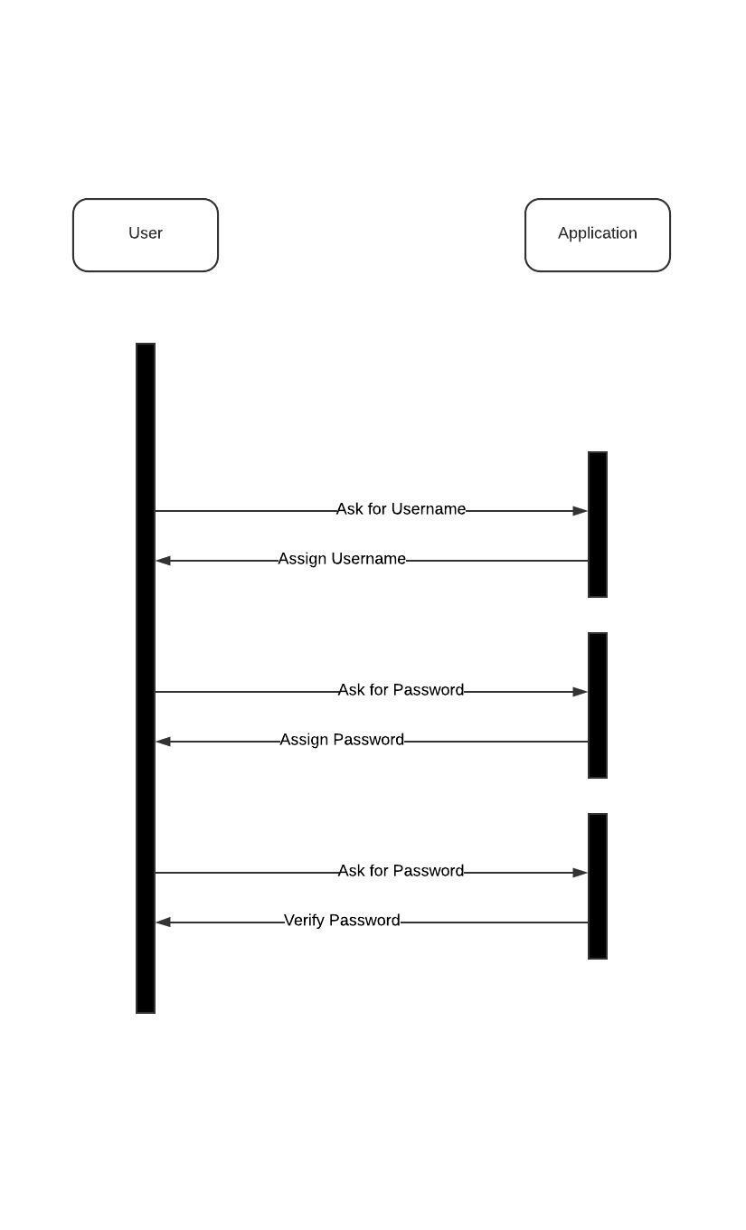

### UML Class Diagram

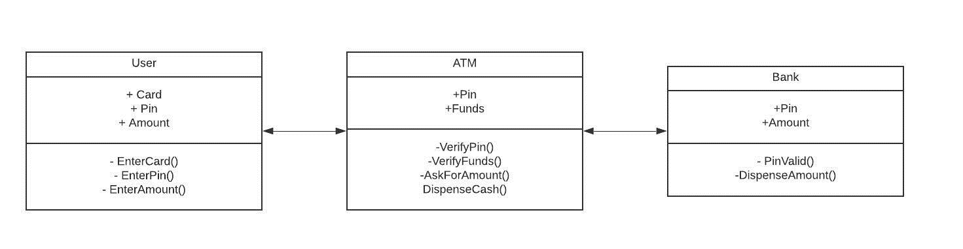

## Technical Requirements

The technical requirements that will be required for this project can be broken down into hardware, software, tools, and infrastructure. The system will need to be hosted on either a server or a cloud computing application. It was also requested to be used from a computer or a cellular device. The software shall be compatible with all web applications and also available in app form for mobile devices. Some of the tools that can be used will be things like organization and database management tools. These tools will need to be used to keep track of and organize its users along with their information. These tools will be used inside the infrastructure to keep things running smoothly for all users and admins. The infrastructure of this program is shown briefly in the UML designs provided. The two instances shown are creating a profile and